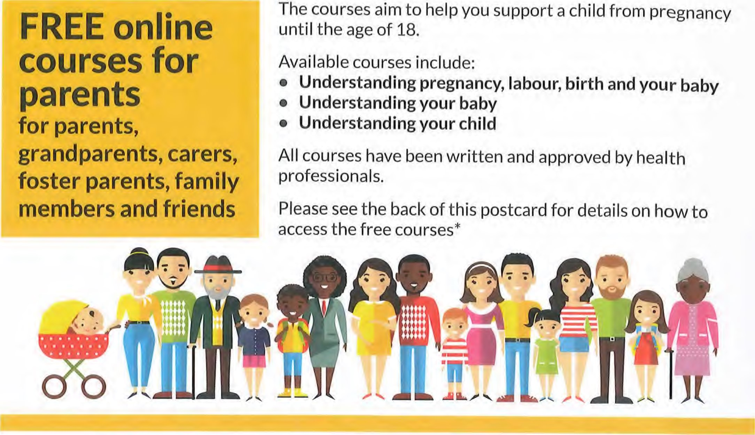
Herefordshire UNDERSTANDING YOUR CHILD
These courses aim to help you support a child from pregnancy until the age of 18.
All courses have been written and approved by health professionals.
*All courses are fully funded by Herefordshire Council and are free to Herefordshire residents
To access the FREE online courses for parents visit: wwwoinourplace.co.uk
Register your details
Enter the Access Code: APPLEHERE
For technical support email: solihull.approach-parenting@heartofengland.nhs.uk or call: 0121296 4448 (Mon - Fri 9am - 5pm)
UNDERSTANDING YOUR CHILO

